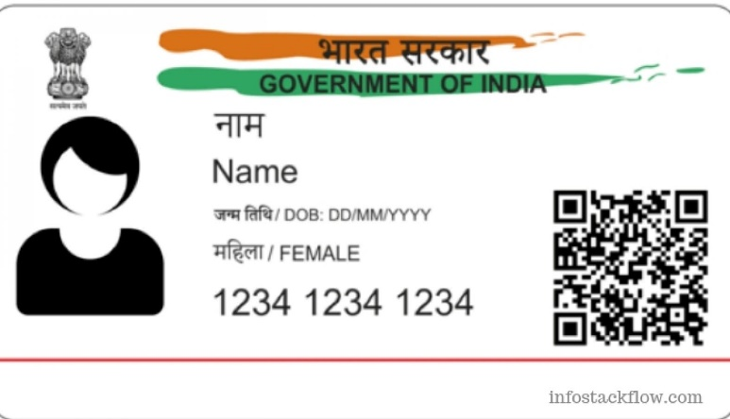

Name -Poonam

DOB-10/10/1999

Gender-Female

4555 0678 1234

Adhaar- Aam Aadmi ka Adhikar

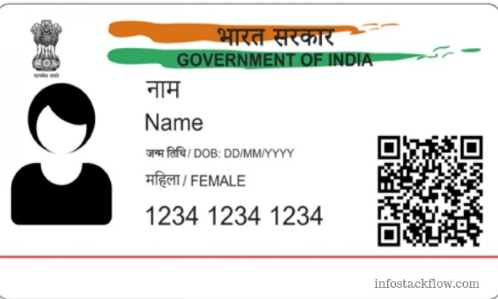

v